Newell Solar
You are receiving this newsletter because you live on or own land near the proposed Newell Solar Project and we want your input.

C&B Alberta Solar Development ULC (CBA) is proposing to construct a solar power plant near Brooks, Alberta. The power plant is designed to generate approximately 13 MW AC and is centered on the SW 20-18-14 W4M, approximately 800m south of the City of Brooks city limit, as shown below.

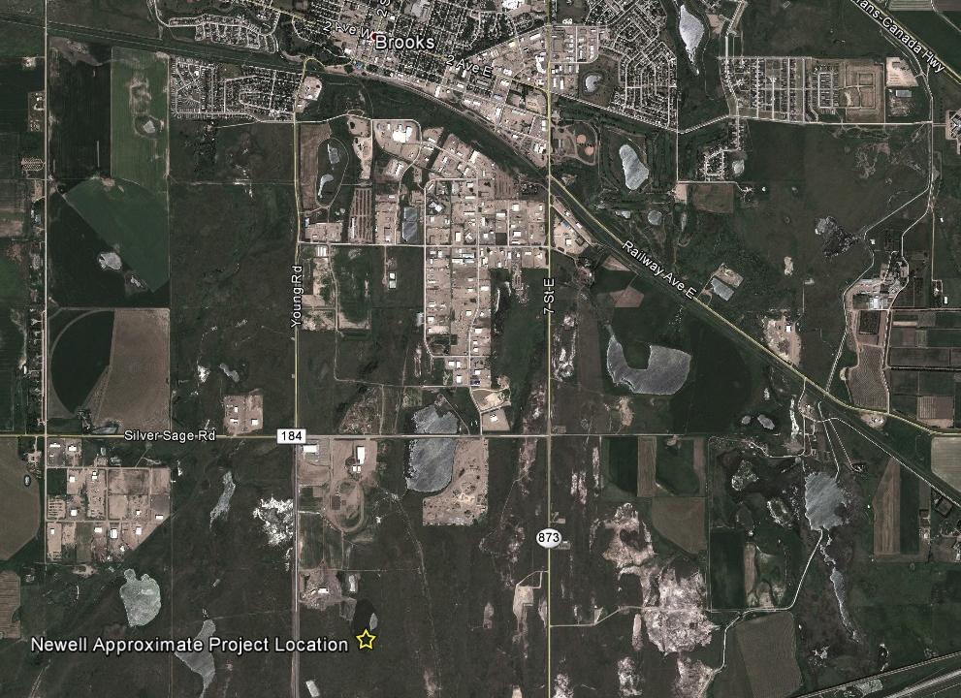
The proposed project, located on agricultural land, has the potential to generate approximately 26 GWh annually, which is enough to power an average of approximately 3,600 households. The total fenced area of the proposed site is approximately 78 acres. Major equipment involved in the project includes:
- Approximately 52,000 solar modules
- Approximately 6 inverter and transformer stations

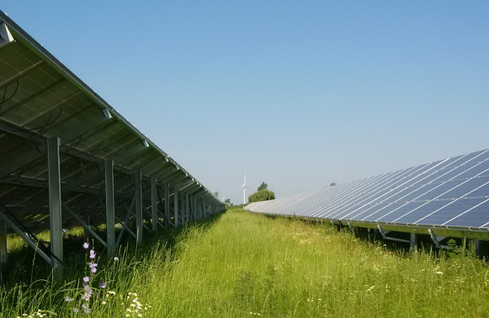
Modules are installed at an angle on racking systems that create “tables” of modules. Each row (table) has space between it complete with vegetation similar to the photo shown here.

Environmental Effects
CBA is committed to mitigating any potential negative environmental impacts and is working with Alberta Environment and Parks (AEP) to complete the necessary wildlife assessment in the area. There are no air emissions associated with the proposal.
Noise
Little or no change to existing noise levels is expected from this proposal. A noise impact assessment will be completed as required by the Alberta Utilities Commission’s (AUC) Rule 012, “Noise Control”.
Project Schedule
Notify Stakeholders | March 2017
Open House | April 2017
File Application with AUC | Q2 2017
Development Permit Application | Q3 2017
Construction | Spring 2018
In Service Date | Spring 2019

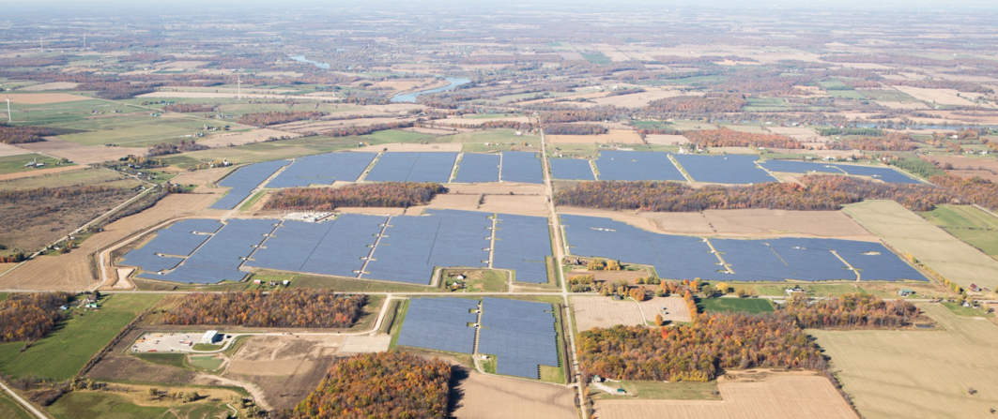
Community Benefits
The proposed solar project will produce clean, reliable electricity for the residents of Alberta. The solar project will reduce the amount of greenhouse gas (GHG) emissions from electricity generation in Alberta by assisting with the Government of Alberta’s plan to phase out the province’s existing coal plants.
The construction of the solar project will create local construction jobs (peak of about 150 workers on site during construction with an average of about 90 workers over the 10 to 12 month construction period). These jobs may include general labourers, equipment operators, electricians, other trades, site managers and engineers.
The construction of the solar project will also create indirect opportunities for worker services (e.g., accommodations, food, entertainment), equipment manufacturing and ancillary service suppliers (e.g., fuel).
During operations, the solar project will also generate additional property tax revenue that will be paid to the local municipality.
Providing Your Input
We will contact landowners, residents and occupants near the proposed project to gather input and address questions or concerns. We are holding an open house in April to provide additional information about the project. After this initial consultation is complete, we will file an application with the AUC. The AUC will review the application through a process in which stakeholders can participate. To learn more about the AUC process and how you can become involved, please refer to the brochure included in this package titled Public Involvement in a Proposed Utility Development.
Project Website:
http://www.newellsolarproject.com
To learn more about the application and review process, please contact:
ALBERTA ULTILITIES COMMISSION (AUC)
780-427-4903 (toll-free by dialing 310-0000 before the number.)
E-mail: consumer-relations@auc.ab.ca

By 2020 Solar Electricity Will:
- Produce approximately 1% of electricity generation in Canada, with almost 6300 megawatts (MW) of installed capacity
- Displace approximately 1.5 million tonnes of greenhouse gas (GHG) emissions per year, the equivalent of removing 250,000 cars and trucks off the road each year.
- Roadmap 2020 - CanSIA
MORE INFORMATION

To learn more about the project and provide input, we invite you to join us at our community open house:

April 5, 2017
Heritage Inn Hotel & Conference Centre
1217 – 2 Street West, Brooks
4:00pm to 7:30pm

A summary of stakeholder comments will be incorporated into the application we submit to the AUC.

